1. Use Case Flow
   1. During graph creation, the graph will recognize where to place a hub
   2. During graph creation, the graph will recognize where to place a station
   3. During graph creation, the graph will recognize where to place a track
2. Use Case Diagram

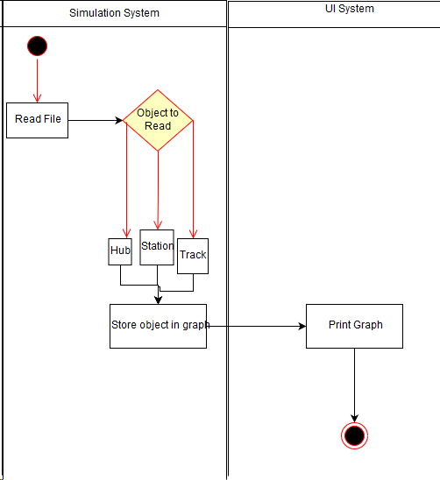

1. ERD

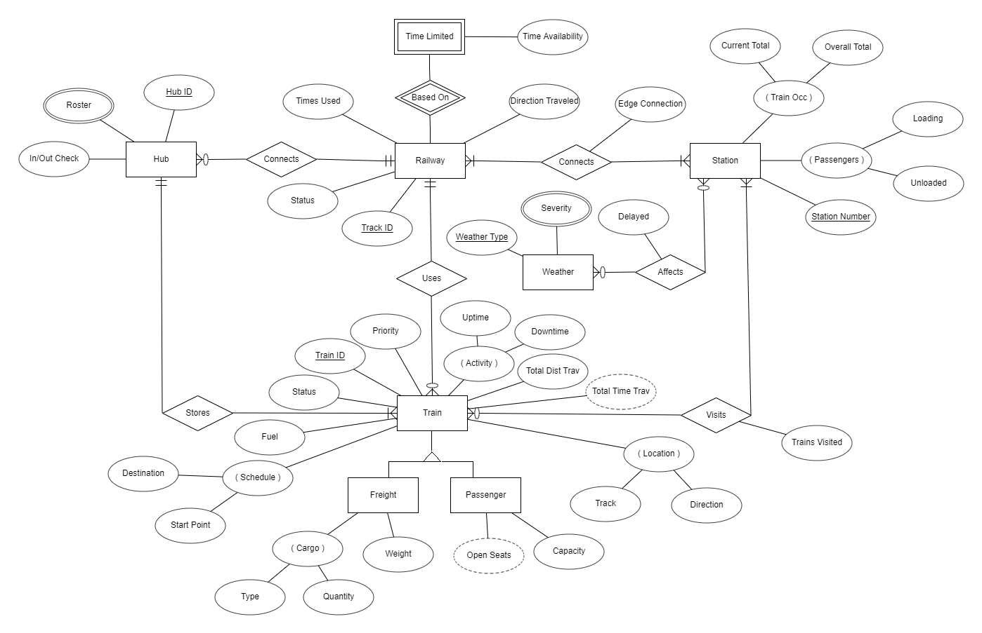

1. DFD
2. 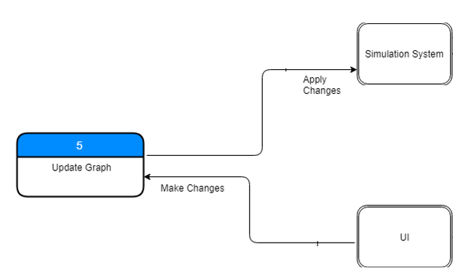
3. Communication Diagram

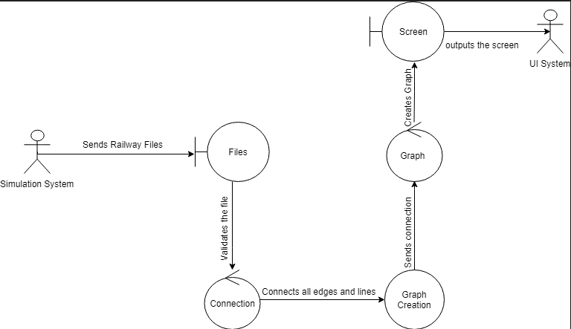

1. CRC Card

N/A

1. 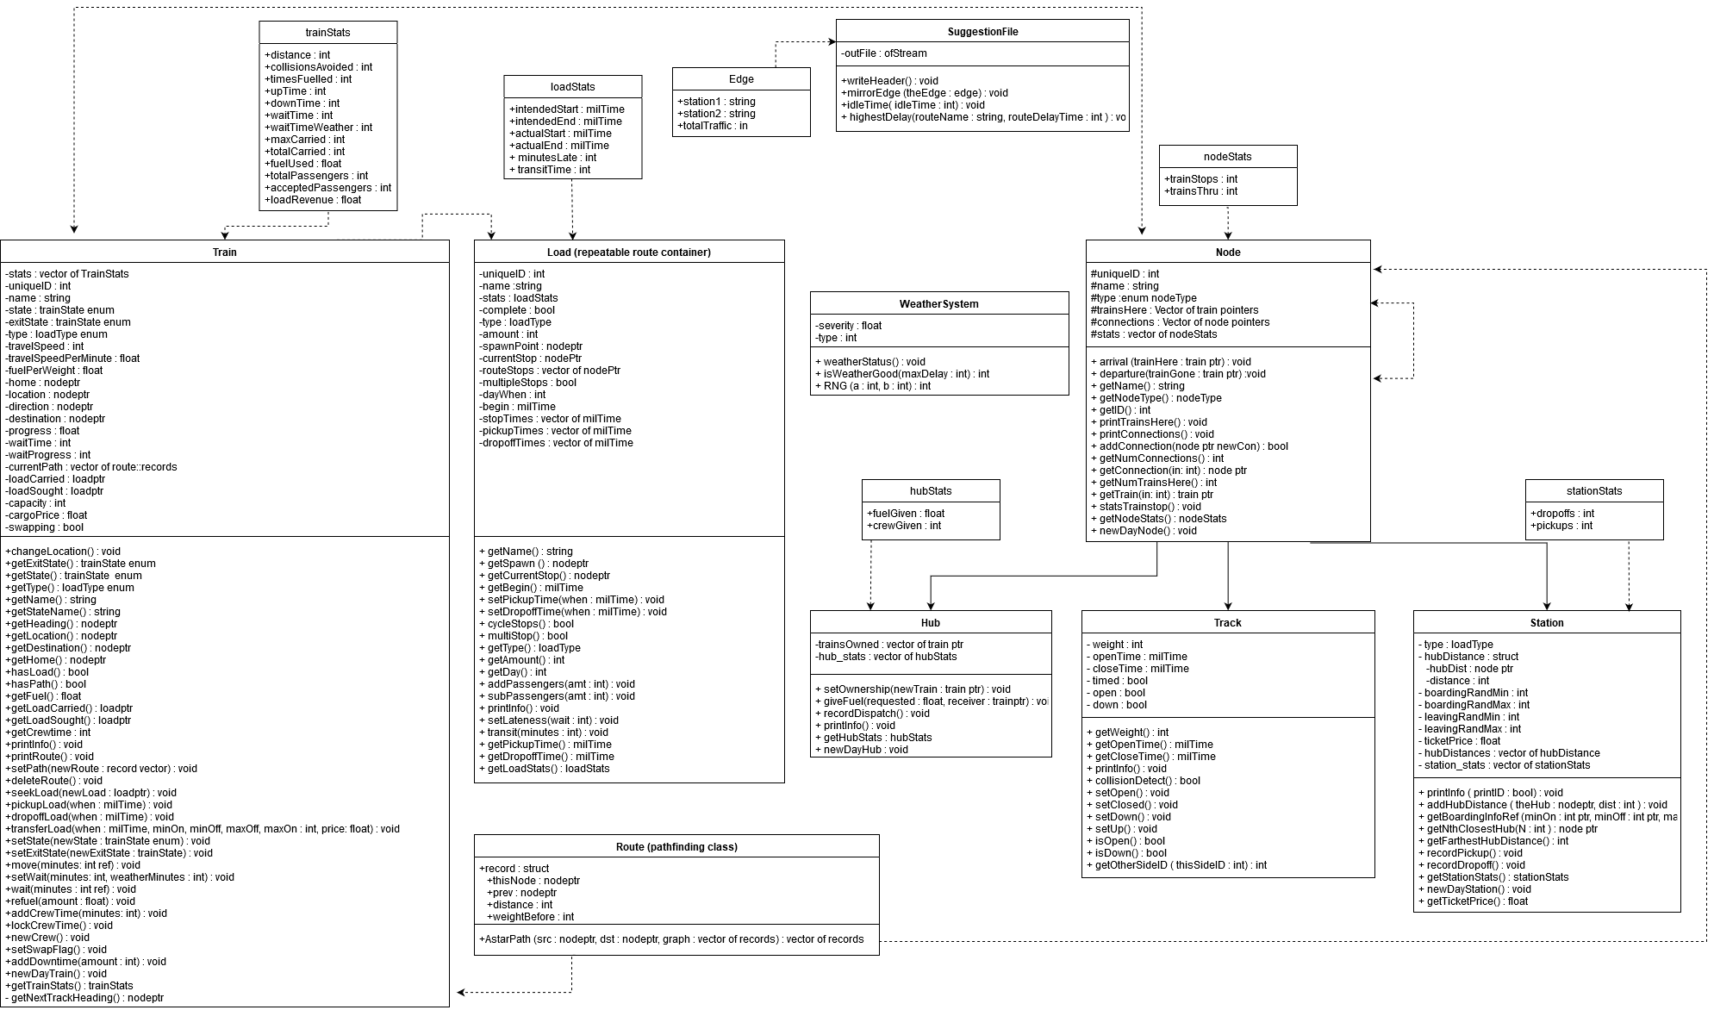Class Diagram
2. Architecture Diagram

N/A

1. Algorithm
3. Sequence Diagram

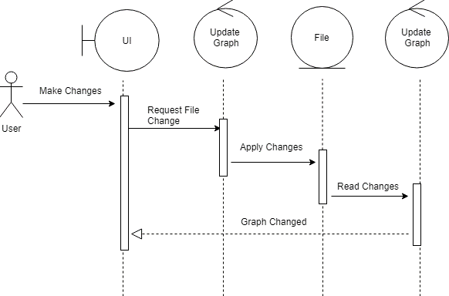

1. 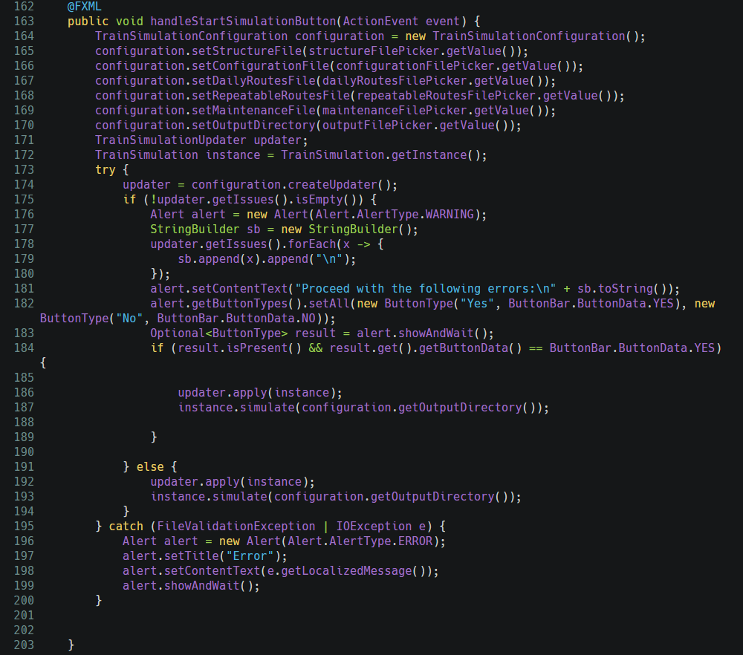Execution